Shakti · TitleClear
TitleClear — Property Documents
Answer a form. Get a real Gujarati legal document.
The problem
In Gujarat, a property document — a sale deed, a gift deed, a rent agreement, a will — is still usually written by hand by a દસ્તાવેજ લેખક (deed writer) sitting outside the sub-registrar's office, charging roughly ₹500 for the first page and ₹250–300 for every page after; a sale deed easily runs past one page. The registration department does publish its own official blank formats for free, on its Garvi portal, but they're dense, formal-Gujarati Word files that almost nobody outside the profession can fill in correctly. Getting it wrong is expensive: stamp duty and registration together typically run to roughly 5–6% of a property's value — well over ₹2 lakh on an ordinary ₹40-lakh flat — and a document rejected at the counter means another trip, sometimes paying again. Nearly every online drafting service, meanwhile, works in English; Gujarati property deeds are the gap almost nobody fills.
The idea
TitleClear turns the government's own official formats into a simple form. Someone picks the document they need — a sale deed, a gift deed, a rent agreement, a will, a power of attorney, and a few others — and answers plain questions, each one shown in both Gujarati and English. As they type, the real document builds itself on screen beside the form, written in the exact formal Gujarati a registrar's office expects: amounts spelled out in words, dates written the traditional deed-writer's way, nothing left for a computer to guess. Typing doesn't even require a Gujarati keyboard — plain English letters convert to Gujarati script as they go. When it's ready, they print it directly or download an editable Word file to hand to an advocate or deed writer to finish.
Pick a document → answer simple bilingual questions → document builds itself → print or download
What it does
- Eight official documents, covering lease, sale, authority, declaration and family transfers — sale deed, agreement to sell, gift deed, release deed, will, power of attorney, rent agreement and affidavit.
- Real Gujarati, not translated Gujarati, amounts spelled out in words, dates written the traditional deed-writer's way, and Gujarati numerals throughout — the phrasing a sub-registrar actually expects.
- No Gujarati keyboard needed, a per-field typing assist converts plain English letters into Gujarati script as you type.
- Multiple parties handled, sellers, buyers, donors, donees, heirs and witnesses can each be added as repeating entries, plus a full property schedule — village, taluka, district, survey number.
- A completeness meter and autosave, so nothing gets lost and it's always clear what's still missing.
- Two ways to take it away, print the deed directly, or download an editable A4 Word file with the wide binding margin deeds use.
Who it's for Anyone buying, selling, gifting or inheriting property in Gujarat — and, over time, the deed writers and advocates who draft these same documents every week and want a faster starting point.
The system design
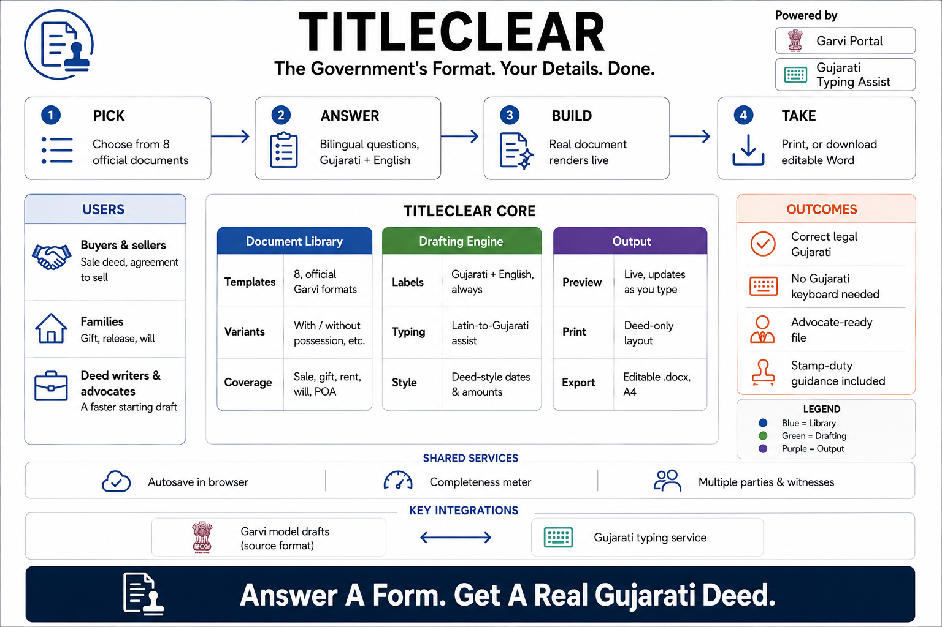
Read left to right: pick one of 8 official documents, answer bilingual questions, watch the real document render live, then print it or download it as Word. The centre panel breaks the engine into three layers — the document library (8 official Garvi formats, with variants like with/without possession), the drafting engine (bilingual labels, Gujarati typing assist, deed-style dates and amounts), and the output (a live preview, a deed-only print layout, an editable A4 .docx) — while the strip underneath names what TitleClear leans on outside itself: the Garvi portal's own model drafts as the source format, and an external Gujarati typing service.
See the drafting screen
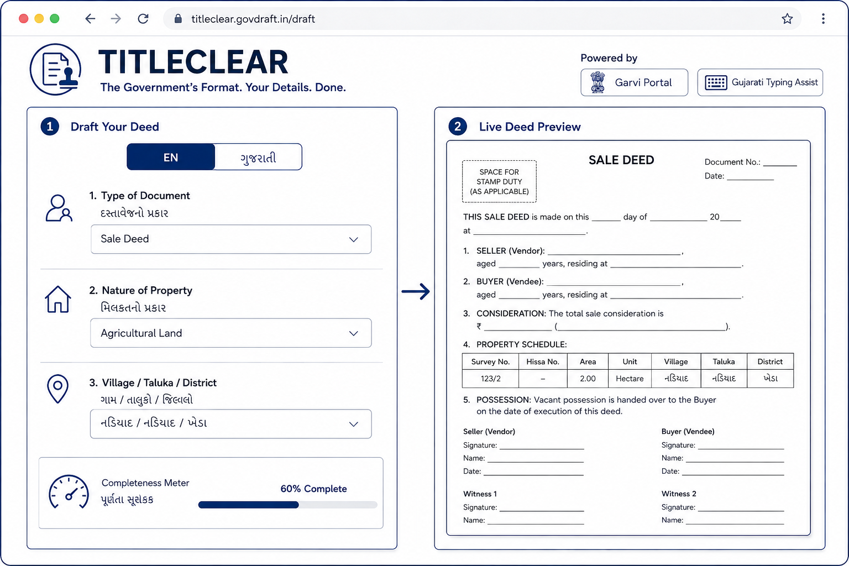
This is the actual product screen. On the left, the three questions someone answers first — Type of Document (Sale Deed), Nature of Property (Agricultural Land), and Village / Taluka / District (નડિયાદ / નડિયાદ / ખેડા) — with a completeness meter reading 60% as they go. On the right, that same information is already sitting inside a real sale deed: a stamp-duty box at the top, the property schedule filled in with the survey number, hissa number, area and village from the form, and blank lines waiting for the seller, buyer, consideration amount, and both witnesses' signatures.
Tell the story — before and after
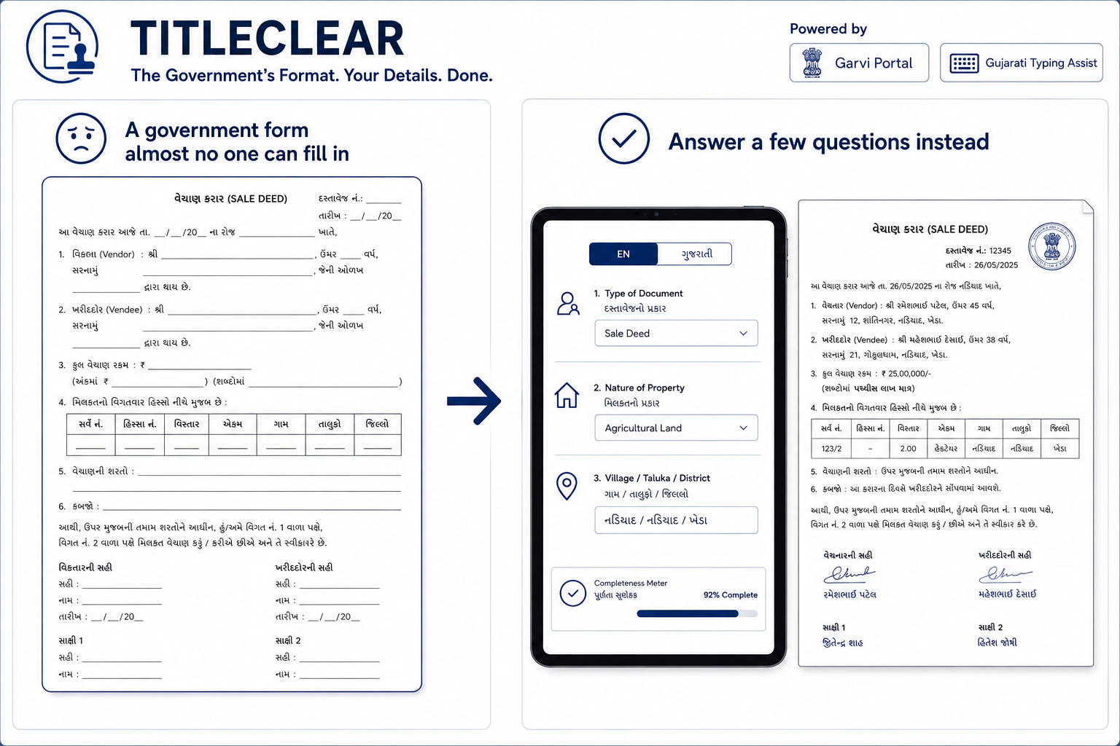
The government's own format, side by side with TitleClear's. On the left, the actual વેચાણ કરાર (sale deed) model draft — dense formal Gujarati with underscored blanks for the vendor, vendee, consideration and property schedule, and nothing to tell an ordinary person what goes where. On the right, the same deed produced from a short bilingual form: Rameshbhai Patel selling to Maheshbhai Desai for ₹25,00,000, the property schedule filled in automatically, and both witnesses already in place — the completeness meter at 92%, ready to download.

